Pymongo Practical

CODE:
import pymongo as pm
import pandas as pd

mycli=pm.MongoClient("mongodb://localhost:27017/")
mydb=mycli["shivam"]
mycol=mydb["student"]
ans=mycol.find()
df=pd.DataFrame(list(ans))
print(df)
OUPUT:
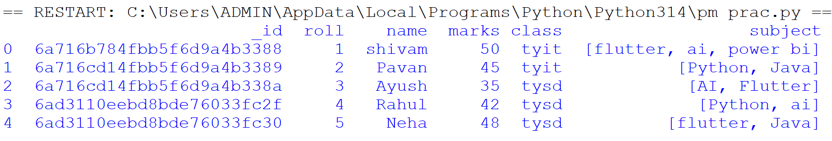

CODE:
import pymongo as pm
import pandas as pd

mycli=pm.MongoClient("mongodb://localhost:27017/")
mydb=mycli["shivam"]
mycol=mydb["student"]
c=input("Enter Student Class: ")
ans=mycol.find({"class":c})
print(ans)
df=pd.DataFrame(list(ans))
print(df)

OUTPUT:
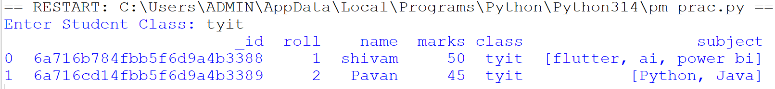
Q). Show the name and salary of the employees whose salary are greater than the user input salary
CODE:
import pymongo as pm
import pandas as pd

mycli = pm.MongoClient("mongodb://localhost:27017/")
mydb = mycli["shivam"]
mycol = mydb["employee"]

d = int(input("Enter Employee Salary: "))

ans = mycol.find(
{"salary": {"$gt": d}},
{"_id": 0, "name": 1, "salary": 1}
)

df = pd.DataFrame(list(ans))
print(df)

OUTPUT:
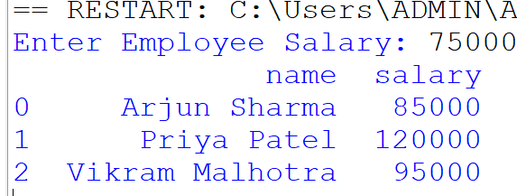

Q). Take user input data and insert it into Mongodb
CODE:
import pymongo as pm
import pandas as pd

mycli = pm.MongoClient("mongodb://localhost:27017/")
mydb = mycli["shivam"]
mycol = mydb["employee"]
a = int(input("Enter Employee id: "))
b = input("Enter Employee Name: ")
c = input("Enter Employee Designation: ")
d = int(input("Enter Employee Salary: "))
e = input("Enter Employee Department: ")
mycol.insert_one({"emp_id":a,"name":b,"designation":c,"salary":d,"department":e})
ans=mycol.find()
print(ans)
df = pd.DataFrame(list(ans))
print(df)

OUTPUT:


